**MUSIC RECORD**

REVIEW REPORT

Submitted by

**SARTHAK BAJAJ (19BCE0710)**

**AVIRAL GOYAL (19BCE0883)**

**KHUSHI AGRAWAL (19BCE0418)**

Prepared For

**DATABASE MANAGEMENT SYSTEM (CSE2004)**

**PROJECT COMPONENT(REVIEW 1)**

Submitted To

**Dr. Nithya S**

**Associate Professor**

**School of Computer Science and Engineering**



**Table of Content**

Abstract

1. Introduction

1.1 Background

1.2 Objective

1.3 Motivation

1.4 Contributions of the Project

2. Project Resource Requirements

2.1 Software Requirements

2.2 Hardware Requirements

3. Design of the Project

3.1 ER Diagram

3.2 ER to Relational Mapping (Schema Diagram)

3.3 Tables and Constraints

4. Implementation

4.1 Introduction

4.2 Implementation

5. Execution

**References(IEEE Style,** Do not give websites in references**)**

**ABSTRACT:**

The music record database project is to categorize and catalog all the songs for their information like their genre, singers, lyricist, from where to download etc. This idea was selected by us due to our common interest in music and also the fact that of ten we remember a song by not its name but by its some other info like album name or singer name and so we wish to provide the users with a space where they can find the music they are looking for or that they desire to listen without surfing through the whole internet.

1. **INTRODUCTION:**

* 1. **Background:**

Music is the backbone of entertainment in this era. It can be considered as the most important part of the society these days. People listen to these to get away from boredom or sometimes to overcome the loneliness too.

**1.2 Objective:**

Finding the right music you like at one spot or in one website is difficult, so we are trying to create such a website which will be a one stop for all the music.

**1.3 Motivation:**

This idea was selected by us due to our common interest in music and also the fact that of ten we remember a song by not its name but by its some other info like album name or singer name and so we wish to provide the users with a space where they can find the music they are looking for or that they desire to listen without surfing through the whole internet.

**1.4 Contributions of the Project:**

|  |  |  |
| --- | --- | --- |
| **Team Member Registration Number** | **Name** | **Work Assigned** |
| 19BCE0883 | Aviral Goyal | Execution of table and constraints |
| 19BCE0710 | Sarthak Bajaj | Drawing ER diagram |
| 19BCE0418 | Khushi Agrawal | Converting ER diagram to relationship schema |
|  |  |  |

1. **Project Resource Requirements:**
   1. **Software Requirements:** Used MySQL Workbench.
   2. **Hardware Requirements:** No specifications required. A device with internet connectivity required.
2. **Design of the Project:**

**3.1 E-R Diagram:**

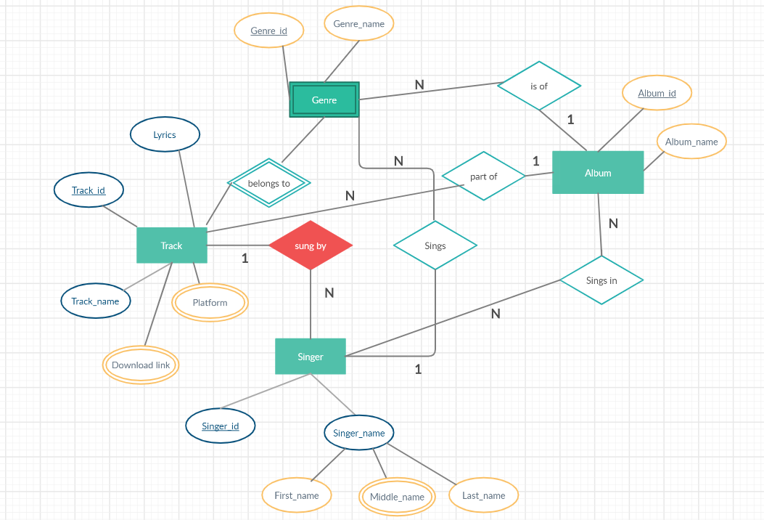

**3.2 Relationship Schema:**

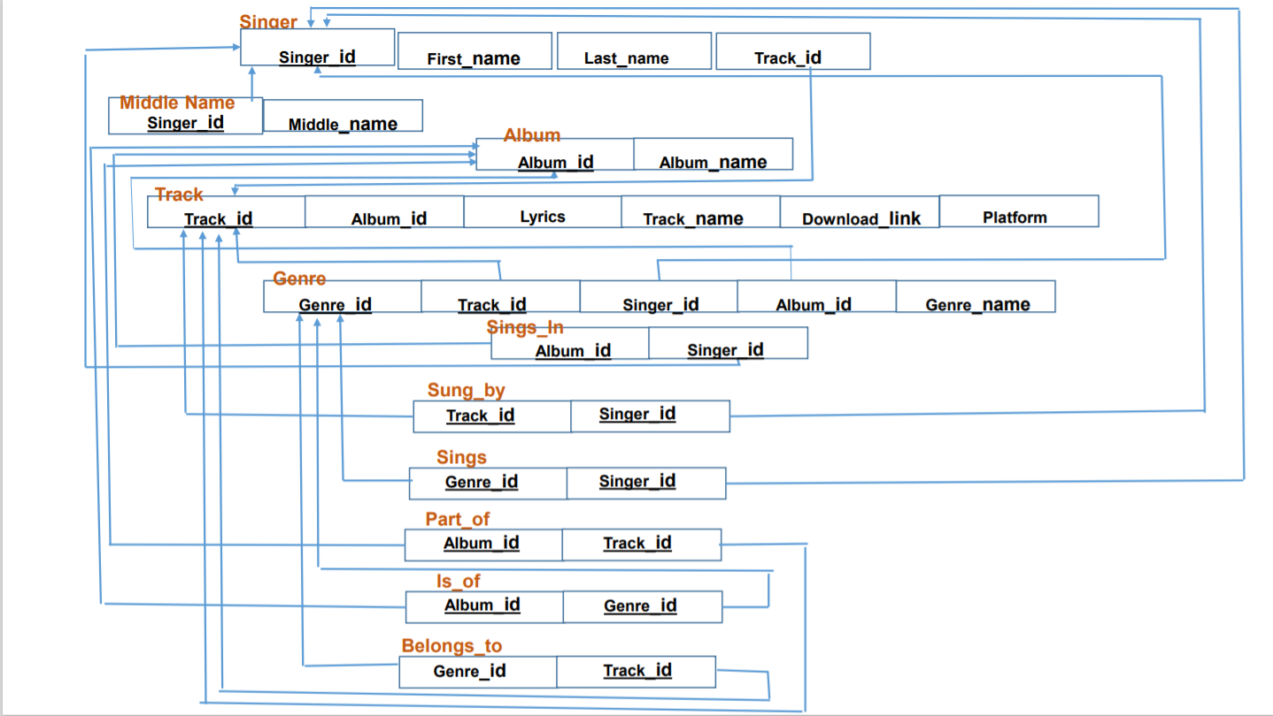

**3.3 Tables and Constraints:**

* Singer:

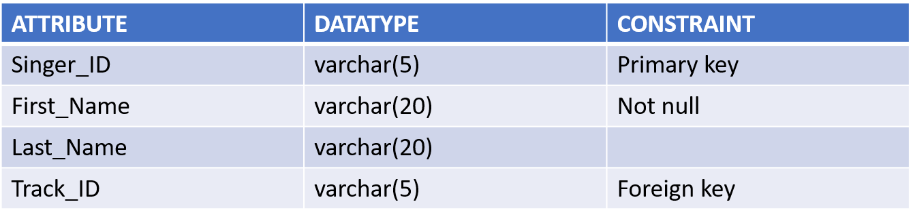

* 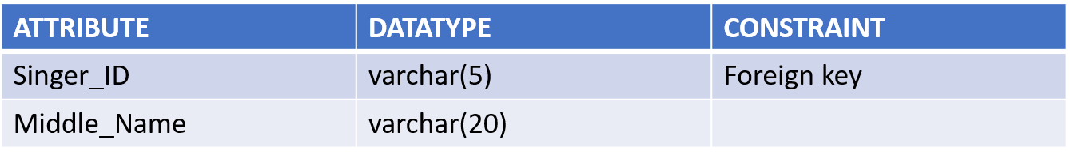Middle Name
* 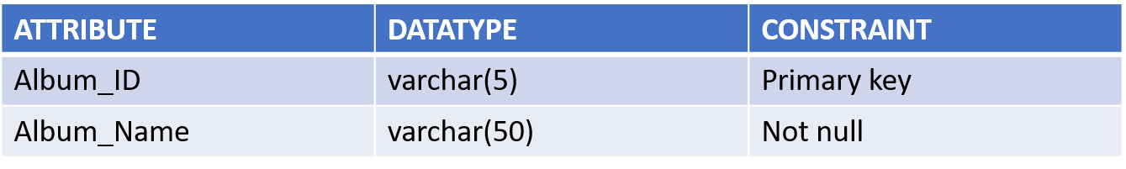Album
* 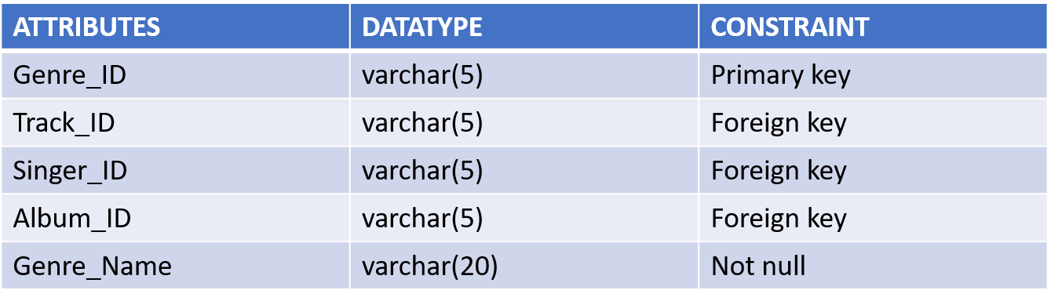Genre
* 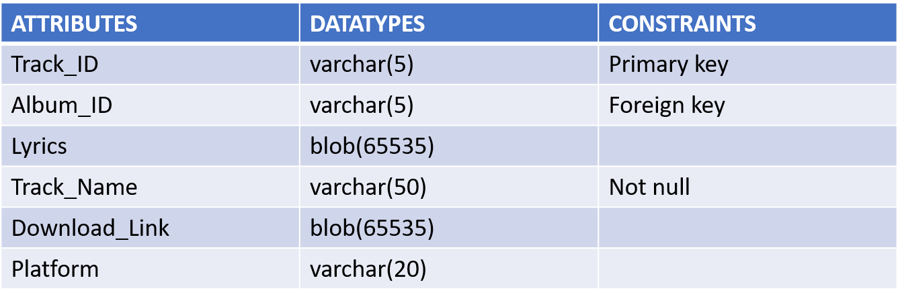Track
* Sings_In
* 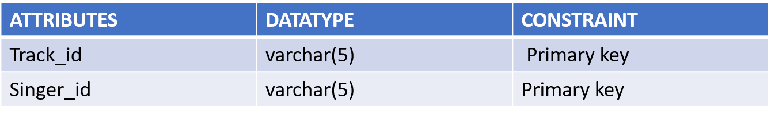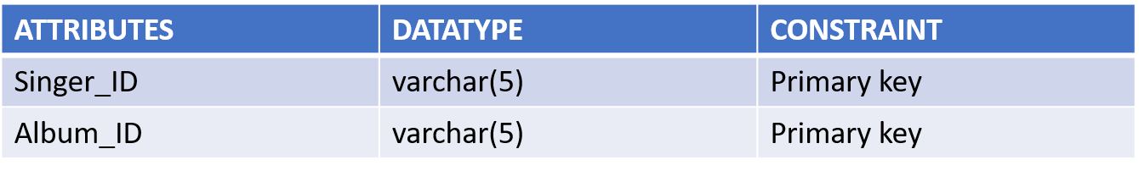Sung_by
* 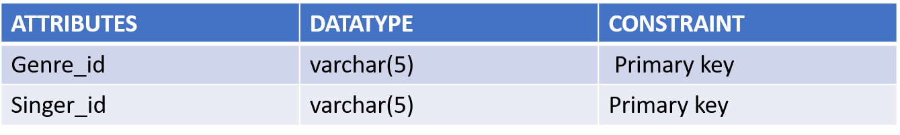Sings
* 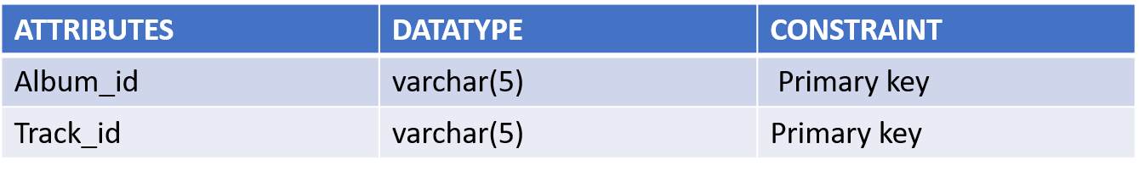Part_of
* 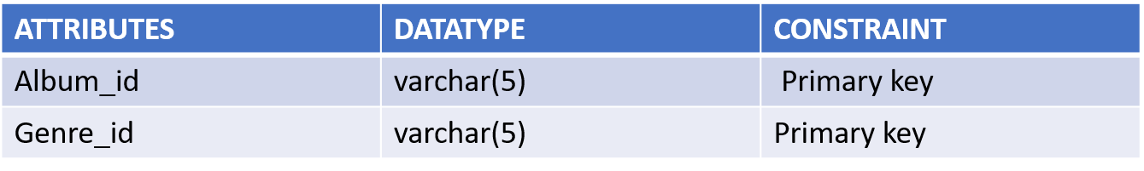Is_of
* 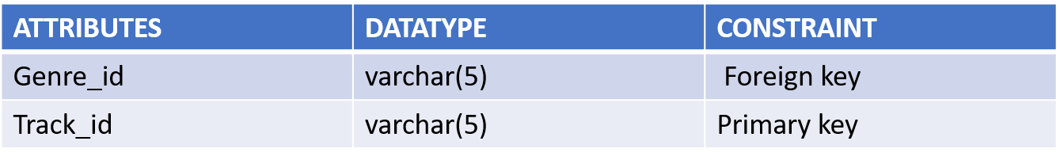Belongs_to

1. **Implementation:**
   1. **Introduction:**

We will create the tables and try to execute them with the correct constraints.

* 1. 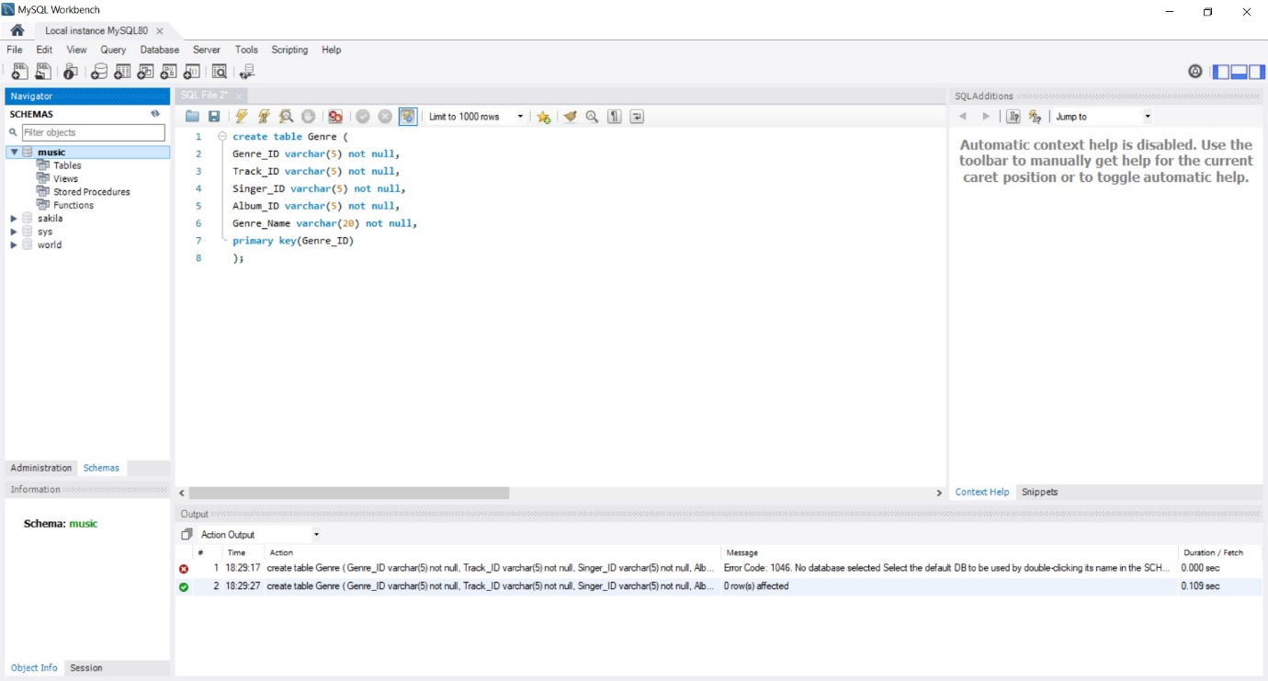**Implementation:**

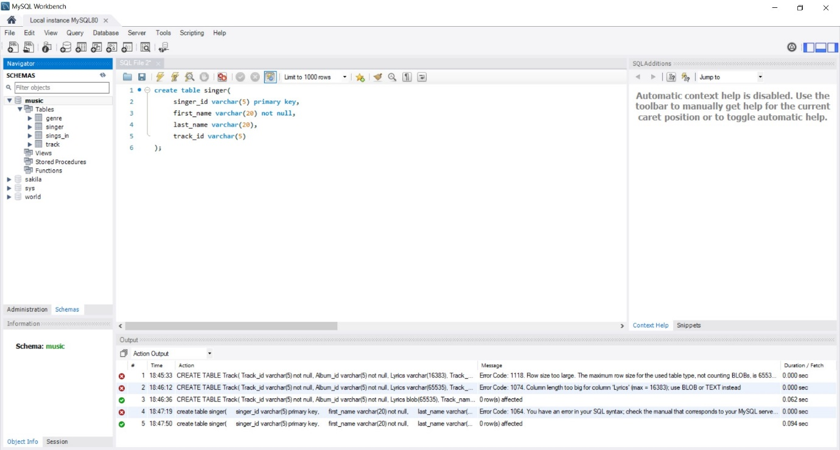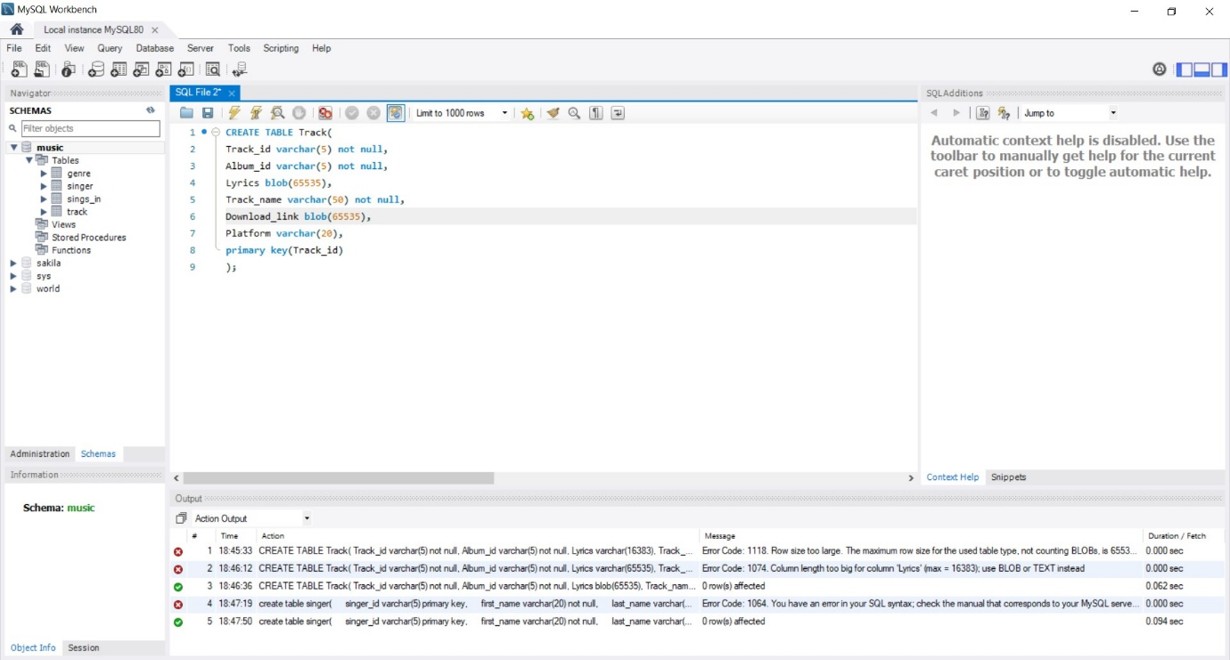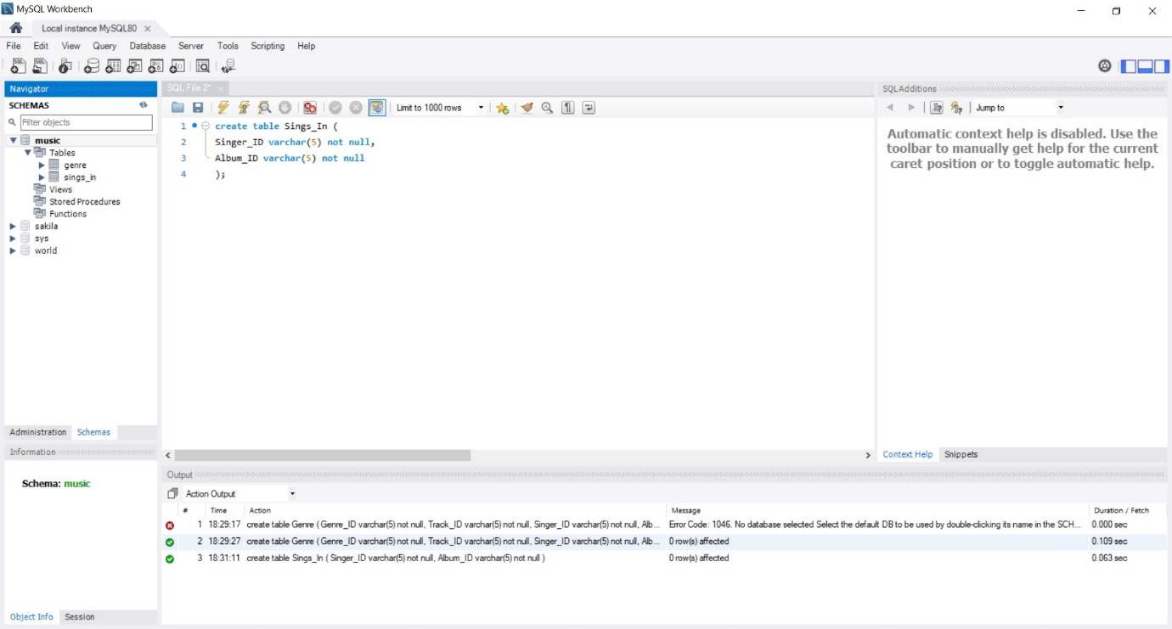

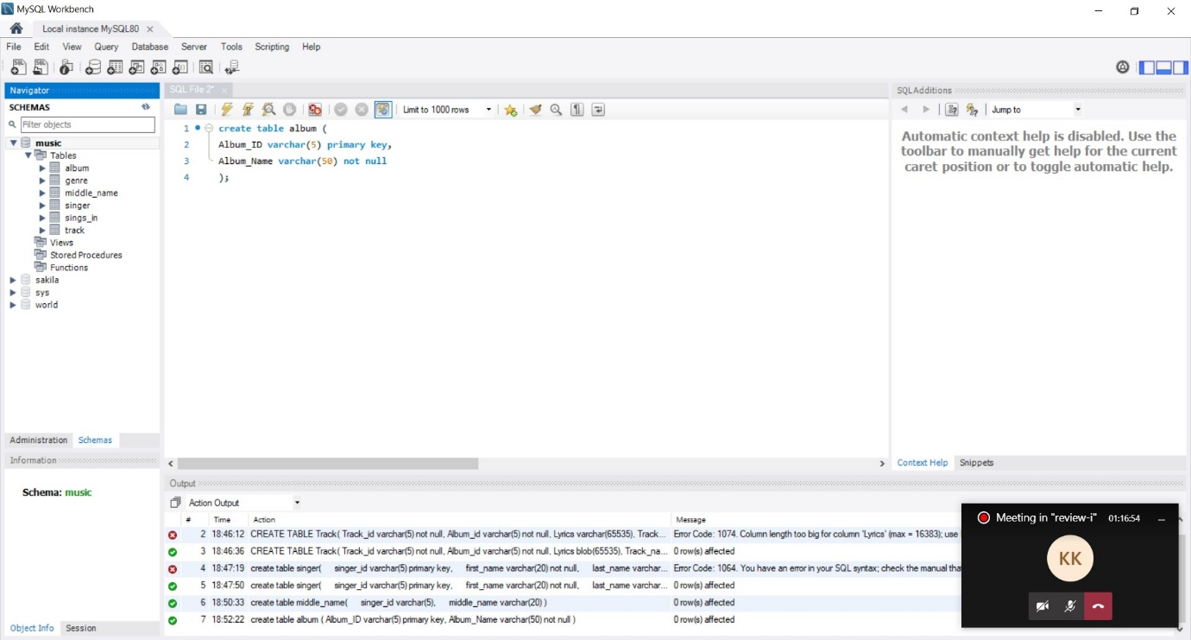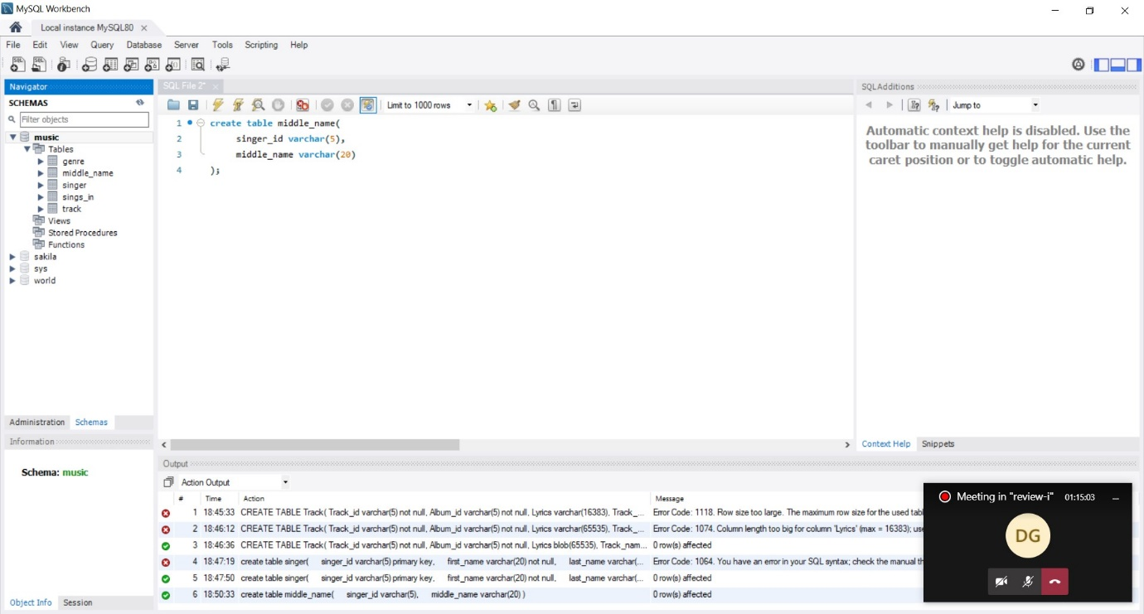

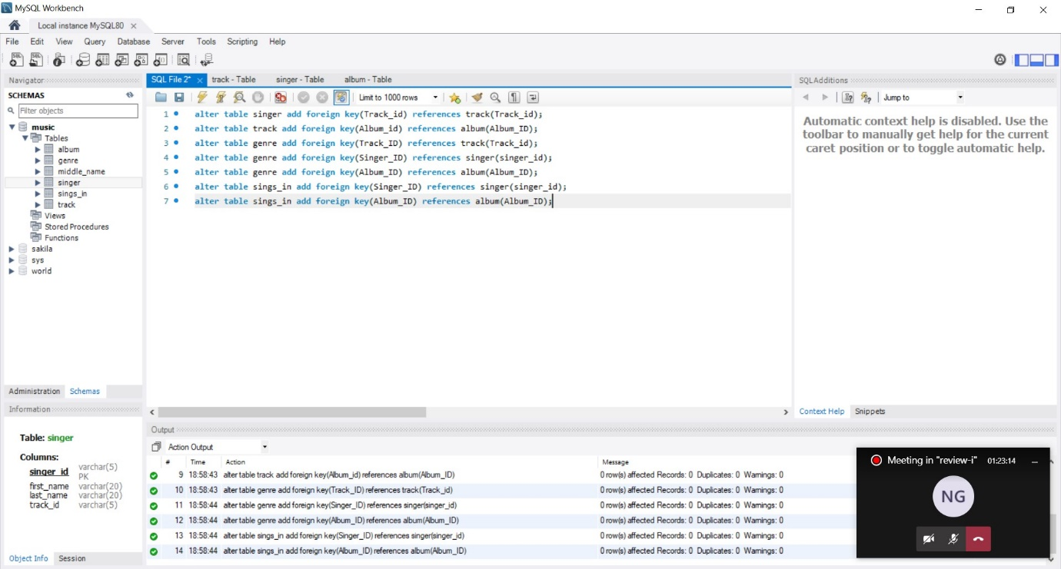

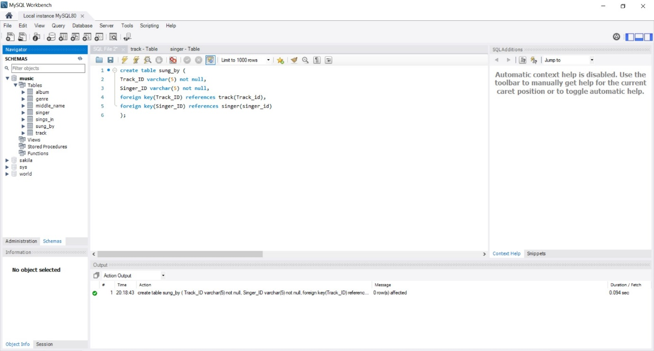

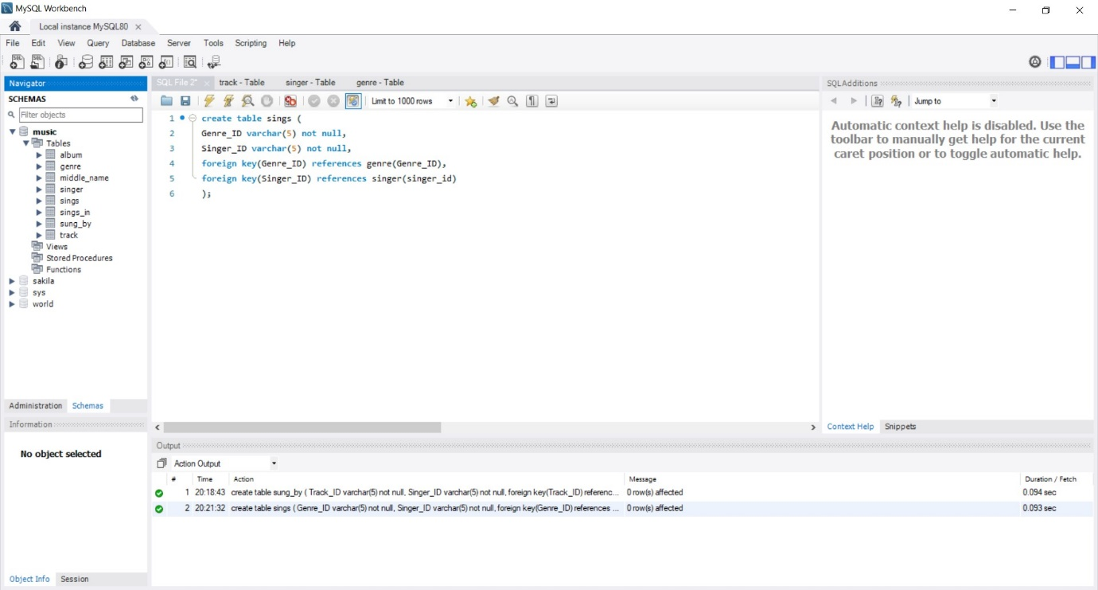

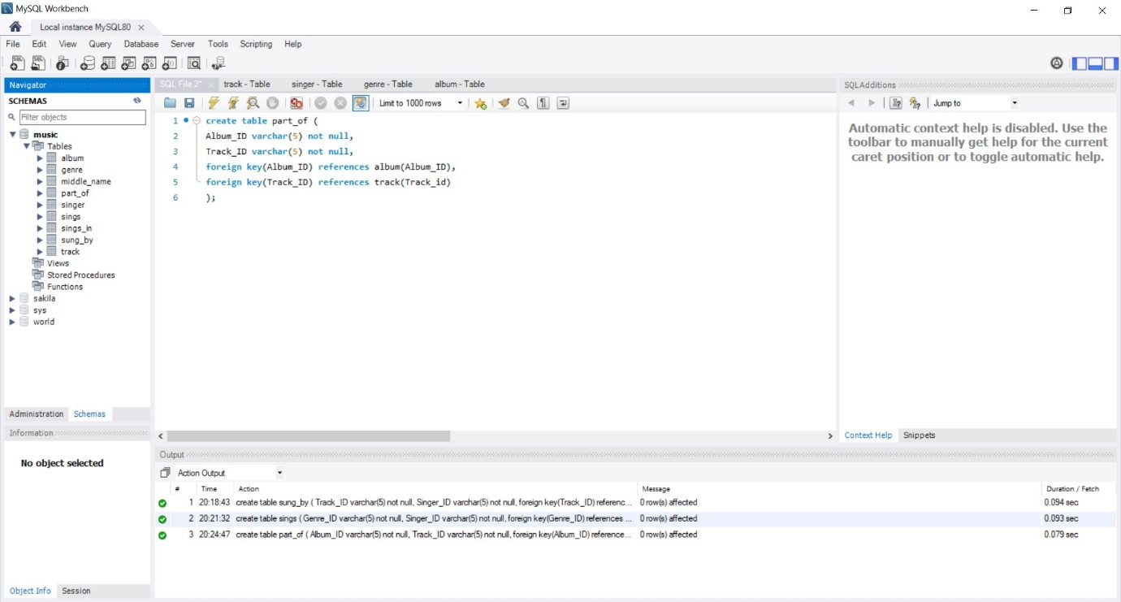

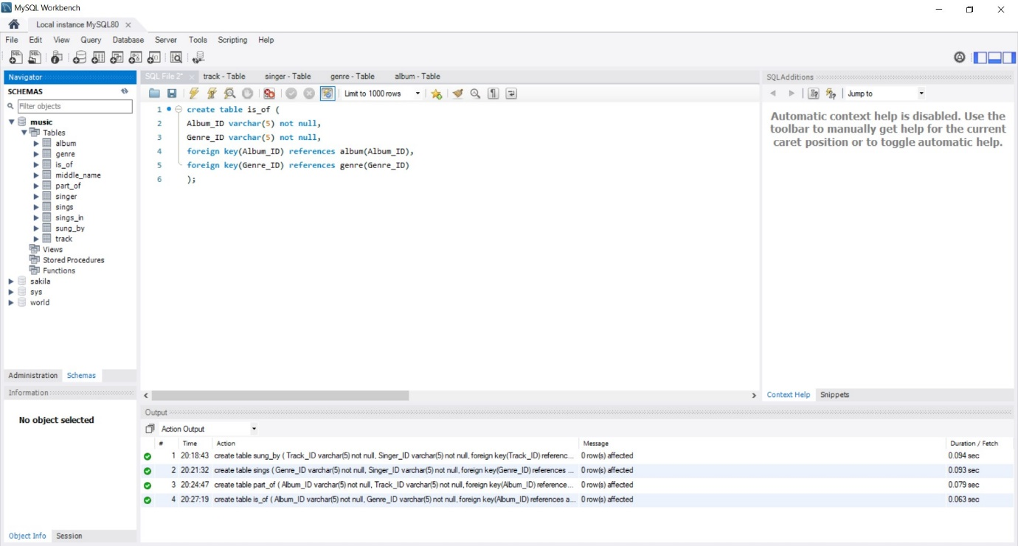

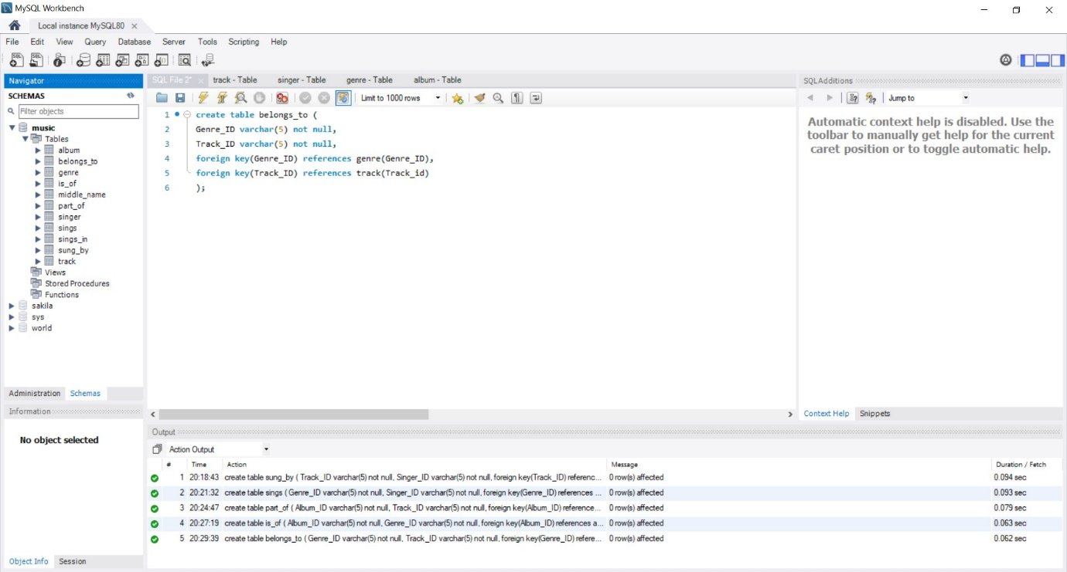

1. **Execution:**

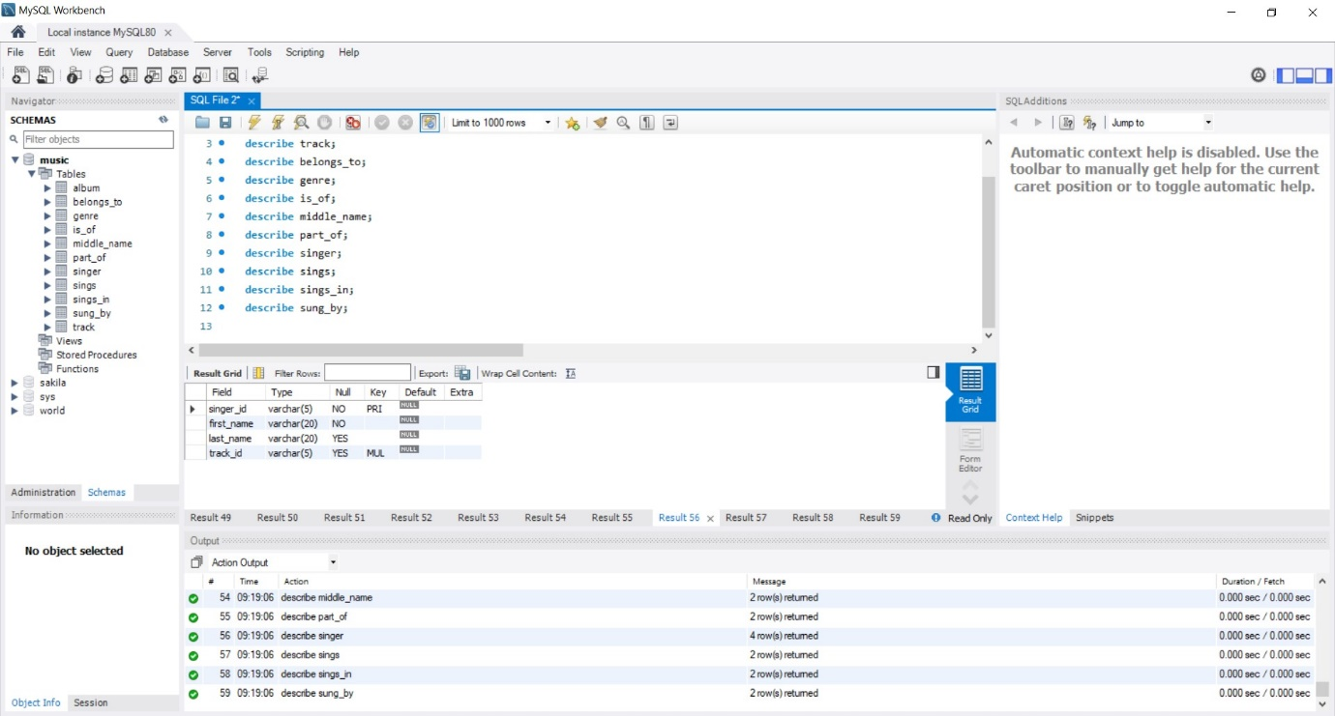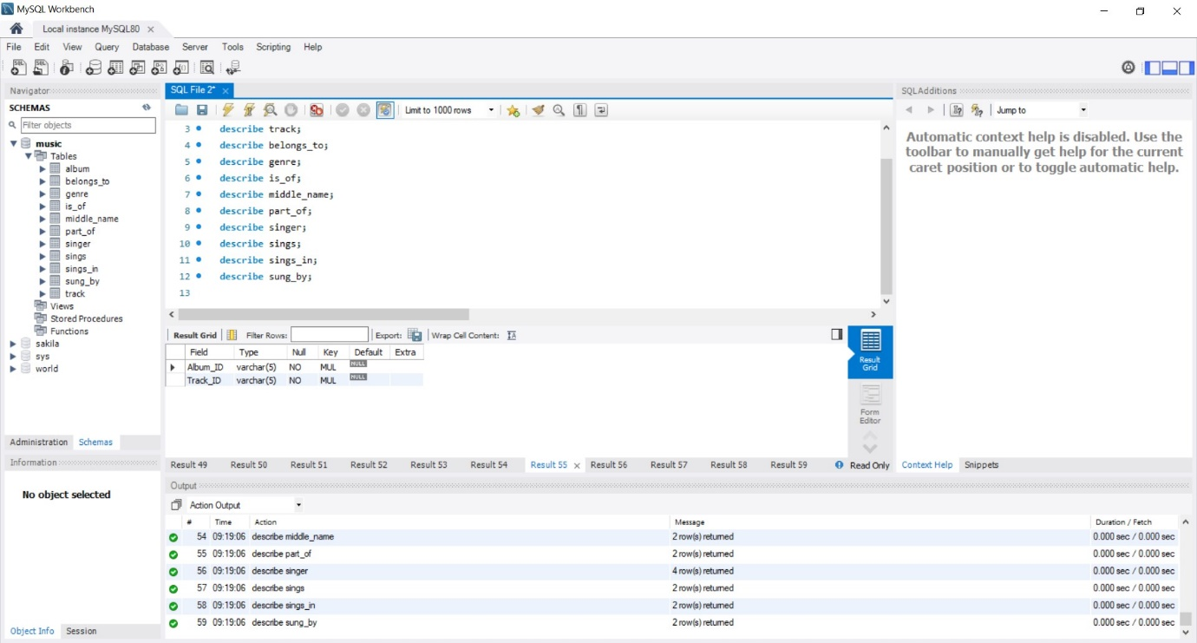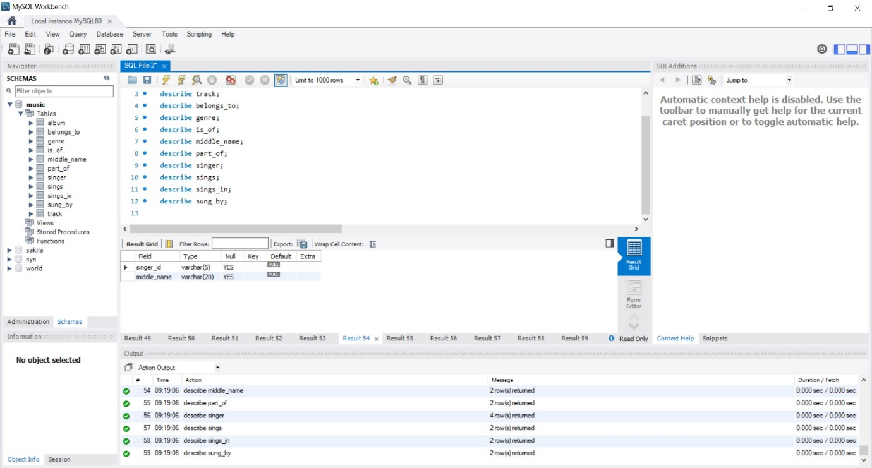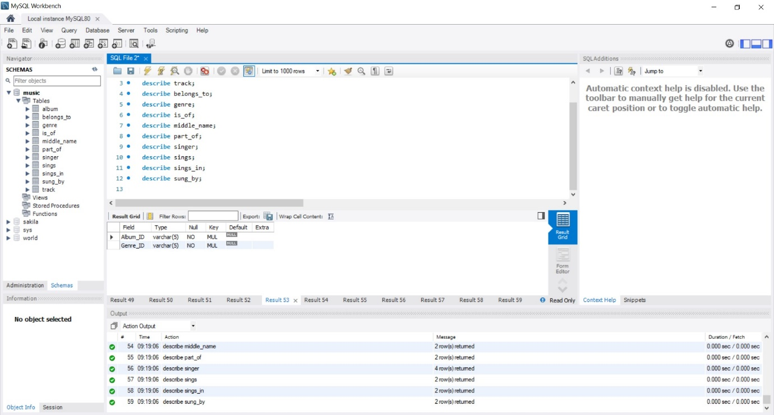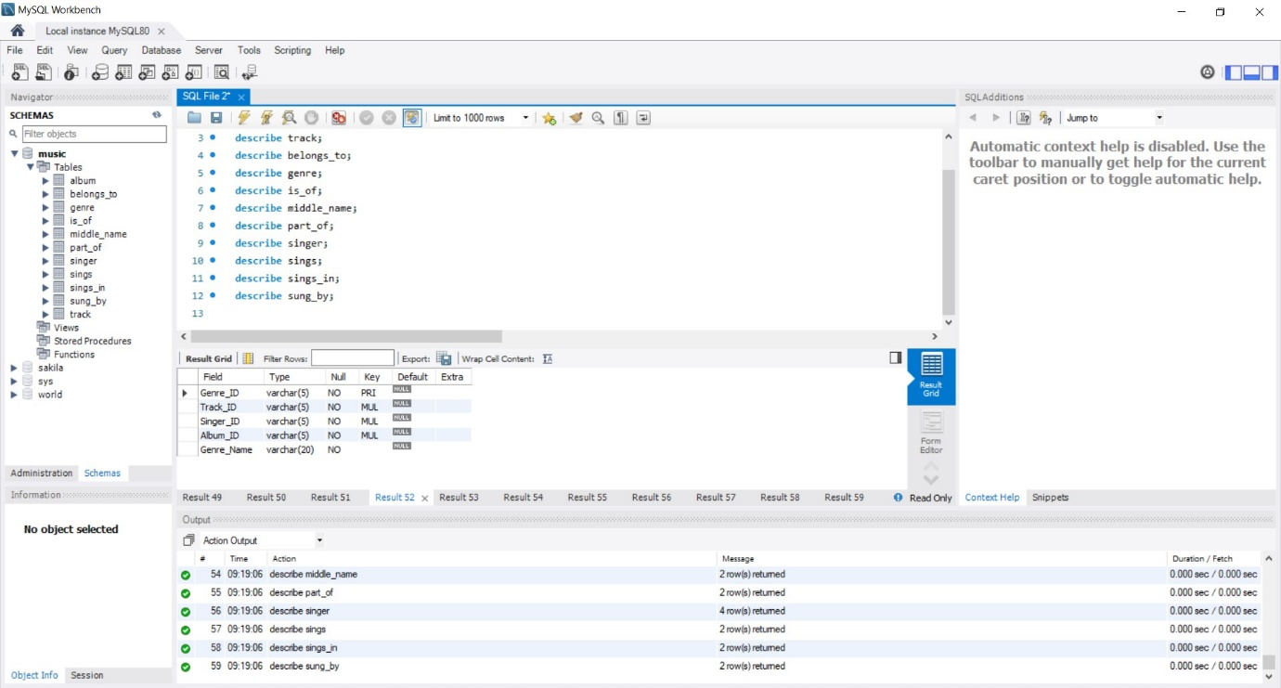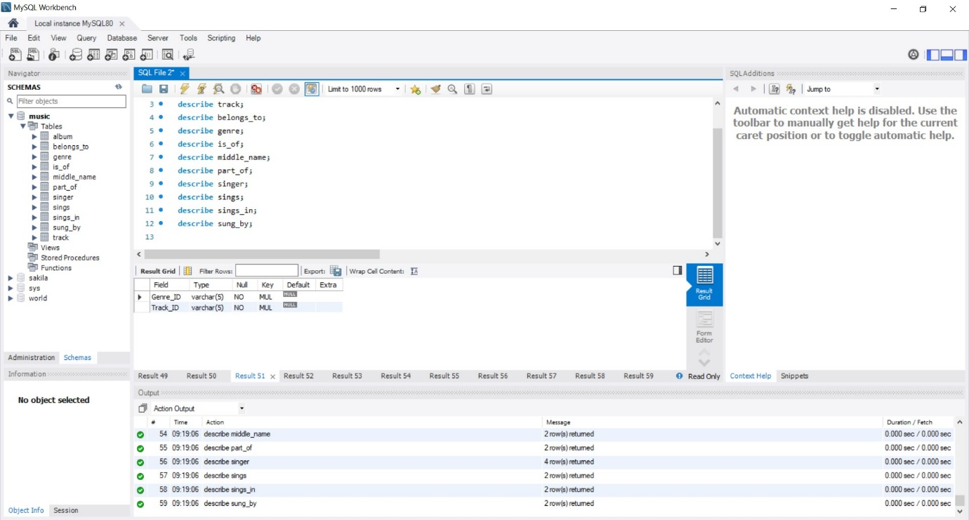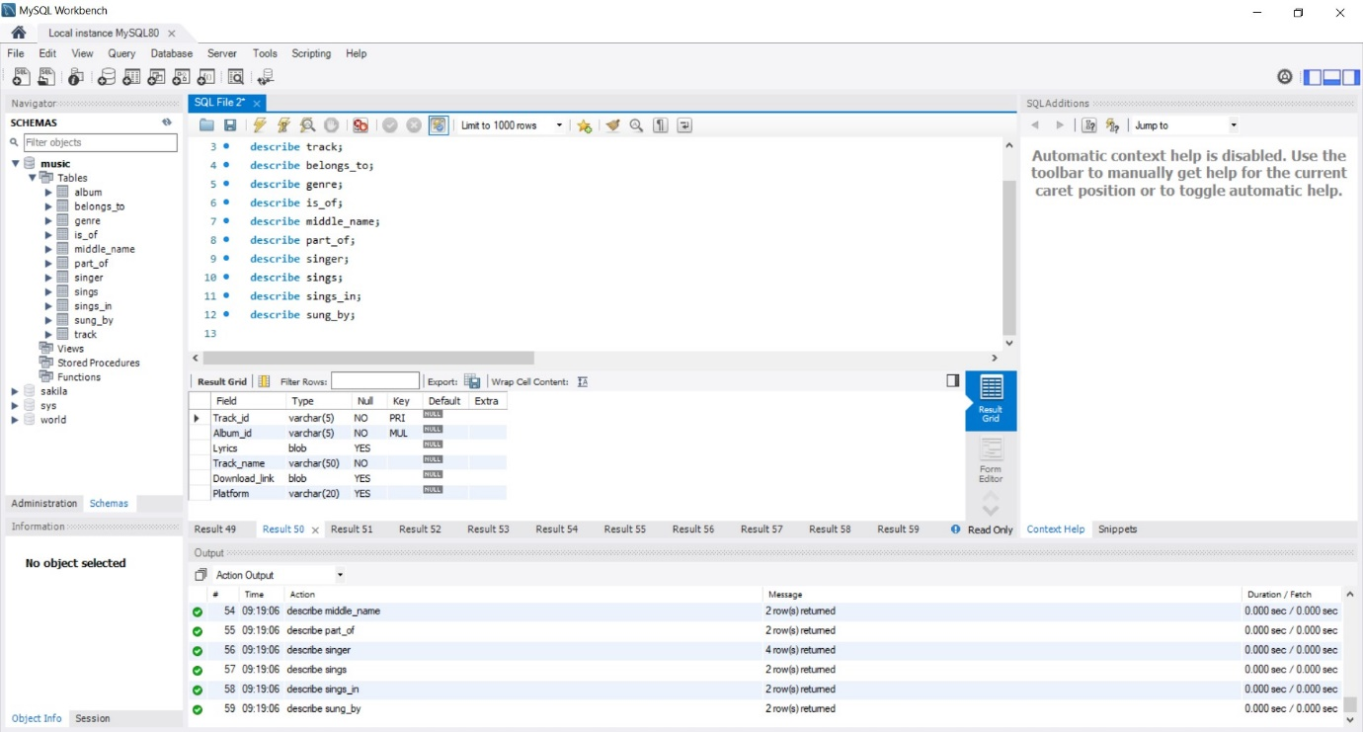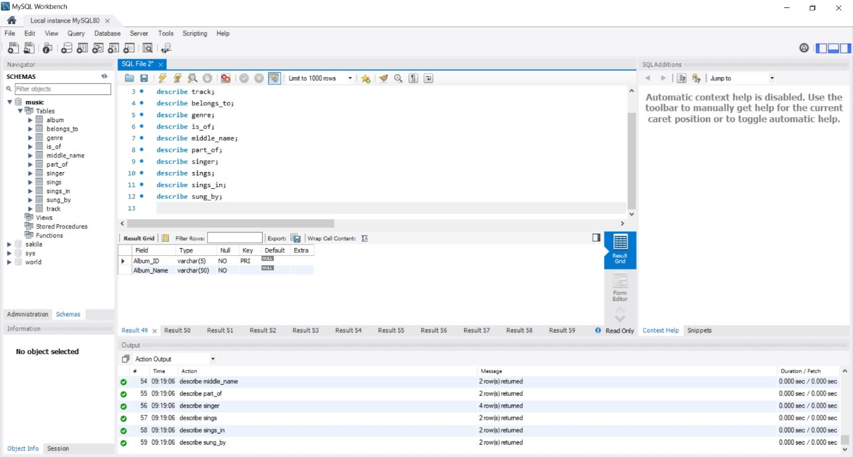

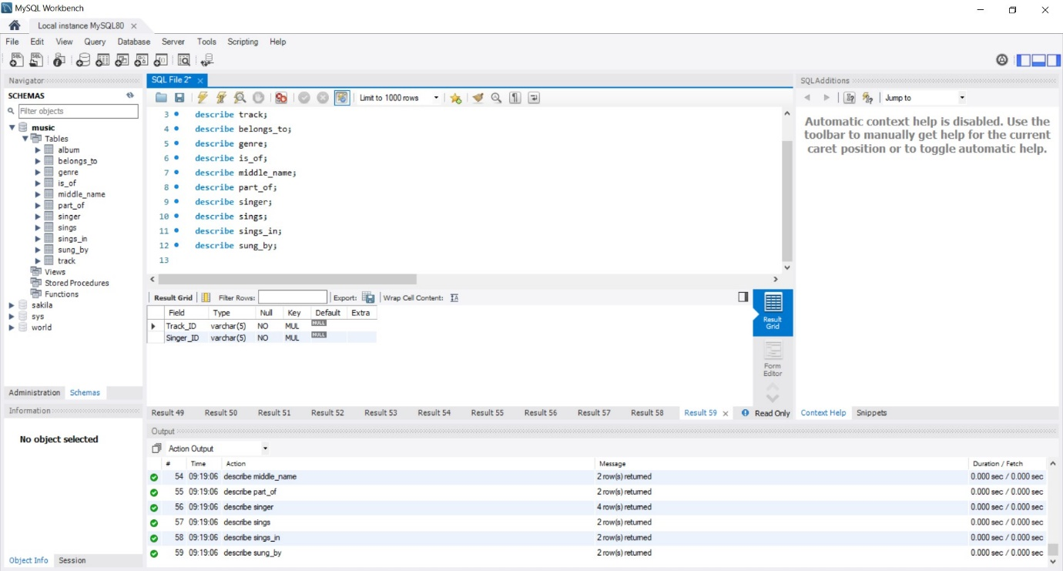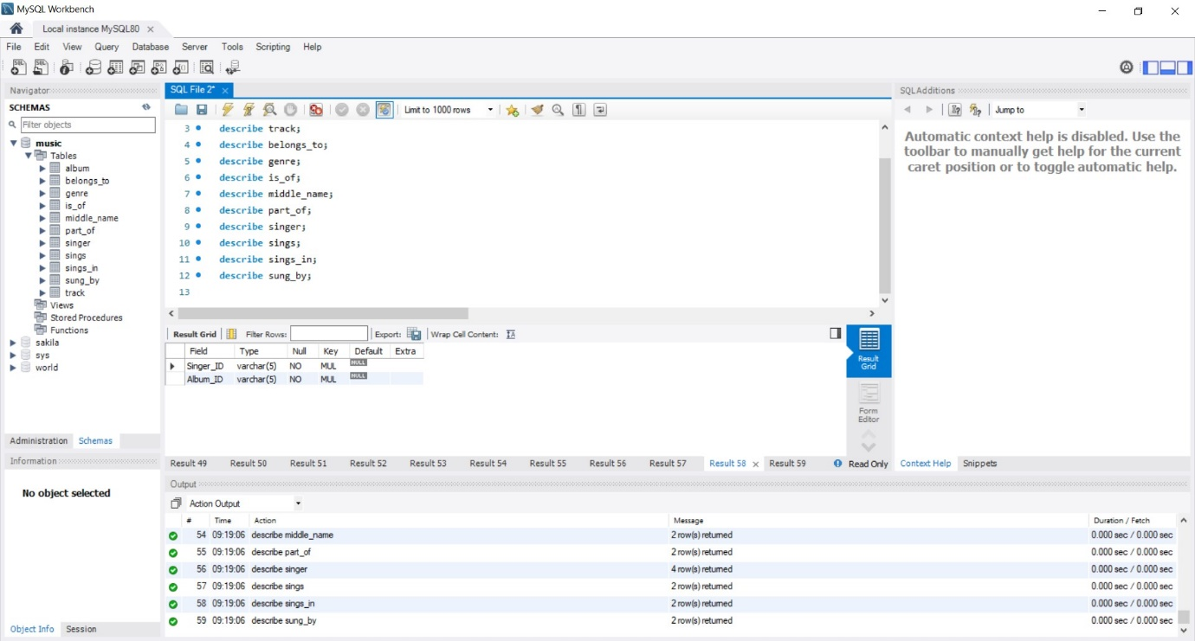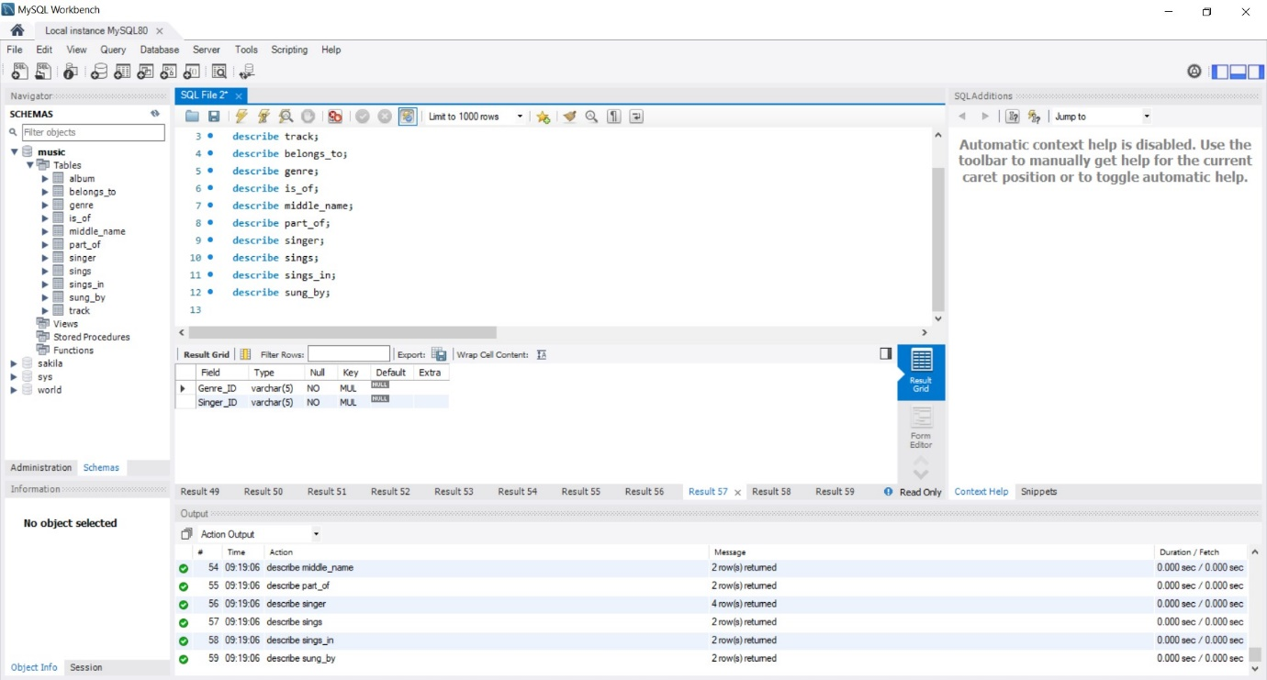

1. **Tables after inserting values**

